Bollington St. John’s Church of England
Primary School
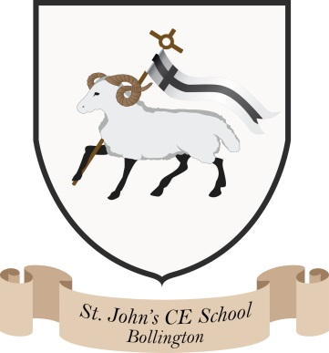
Where talent grows
Head Teacher: Mrs M. Walker
Head of Teaching, Learning and Assessment: Mrs E. Watson
“Whatever you do, work at it with all your heart, as working for the Lord”
Colossians 3:23

PSHE/RSE overview
We have created a bespoke curriculum map for PSHE/RSE/Wellbeing throughout our school based on the PSHE association programme of study, Chris Winters Sex Education and the No Outsiders relationships scheme of work.
PSHE is taught weekly and assessed using bespoke assessment grids by both pupils and teachers. Class discussions, picture books and online resources form the basis of these lessons which are recorded in individual wellbeing books. Reception has a class concept book.
Sex Education is taught in every year group termly using the Chris Winters resources. The new lessons have an increased our focus on families, relationships, safeguarding/keeping children safe. We also focus on the additional units covering Respect and Equality and FGM. This resource encourages children to develop the skills of listening, empathy, talking about feelings and relationships with families and friends.
Relationship education is taught using the No Outsiders programme which is based on high quality picture books, which also contribute to class reading spines. Each lesson taught through a picture book, promotes a respect for diversity through education in schools. The programme is centred on the promotion of dialogue to counter fear and hate in society. This links closely with our global work and Philosophy for Children (P4C).
Children have wellbeing/mental health focused lessons once every half term. We follow the myHappymind scheme of work.
Mental health ambassadors are linked to the local high school. The children visit regularly and plan assemblies, events and presentations for the school.

