“Give thanks to the Lord for He is good; His love endures for ever” (Psalm 106 v 1)

Happy new Year to all KNAPS sponsors and friends praying that you and your family have a Blessed, Healthy and Happy Year.

Sadly, owing to Covid restrictions Alan and I have not been able to visit Uganda in person, but have been able to communicate using ZOOM and WhatsApp technology. We are praying that we will be able to arrange a visit in the next few months.

Good news – The schools are now fully re-opened and below are some photos sent by Headteacher Dan.

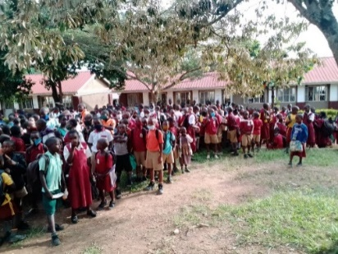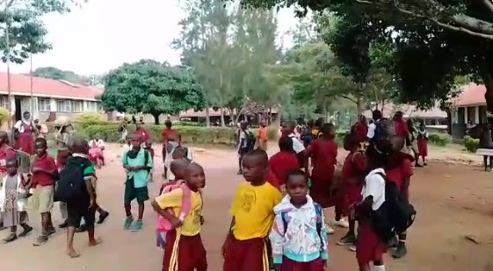

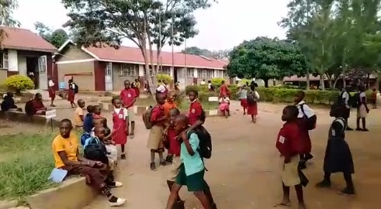

Happily though separated by distance, during the last 18 to 20 months we have been able to assist many families. We sent money on various occasions via our friends Joseph and Allen to purchase food for needy families (the Ugandan lockdown caused many to lose jobs). Also Allen and the Revd. Ian were able to distribute money for Christmas 120 meals around Kamutuuza.

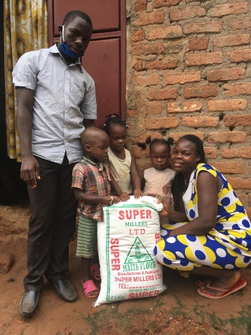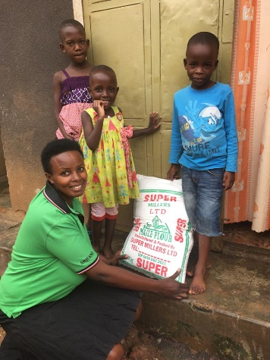

Alan and I were able to provide funds for new wells that were completed in local villages around Kamutuuza.
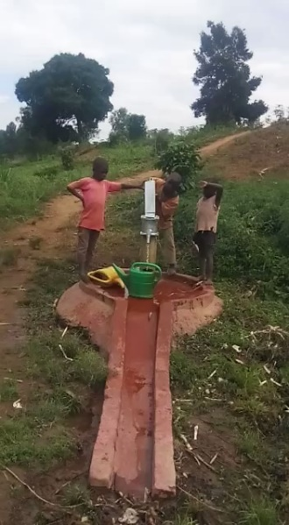

Some special Just Care donations enabled the new Boys’ Dormitory to be built and is now completed and in use. The old dormitory is being re-furbished back into two classrooms.

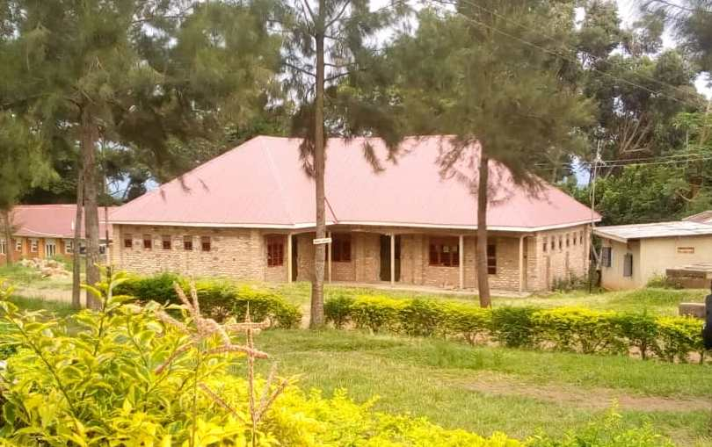

Also the families and carers of children in the Evelyn’s Home Scheme were helped by gifts of food via Gareth and Dana.

Because of your love and concern, via the KNAPS Sponsorship we continue to support the children on Tower Campus and beyond. We will be able to give you further updates and how your support can be best used after our next visit

Doreen McGraa
KNAPS Co-ordinator
Just Care

