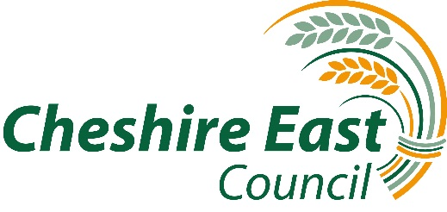

INSTRUMENT OF GOVERNMENT

- The name of the school is Bollington St John’s Church of England Primary School

- The school is a voluntary aided school

- The name of the governing board is “The governing board of Bollington St John’s Church of England Primary School”

- The governing board shall consist of:
1 Headteacher Governor (ex-officio)
1 Staff Governor
2 Parent Governors
8 Foundation Governors
1 LA Governor
1 Co-opted Governor

- Total number of governors will be 14 (except at any time when the Headteacher has given notice to the clerk to the governing board that s/he chooses not to be a governor, when the total number of governors will be 13)

- The term of office for all governors is 4 years

- The Foundation Governors, other than the ex-officio Foundation Governor, shall be appointed by the Chester Diocesan Board of Education in consultation with the Parochial Church Council of Bollington.

- The holder of the following office shall be a foundation governor ex-officio:

  - The principal officiating minister in the Parish of Bollington
  - The Archdeacon of the Archdeaconry within which the school is situated shall appoint a foundation governor to act in the place of the ex-officio foundation governor whose governorship derives from the office named in a) above, in the event that the ex-officio foundation governor is unable or unwilling to act as a foundation governor, or has been removed from office under regulation 23(2) of the regulations

- There is a trust for the school

- Recognising its historic foundation, the school will preserve and develop its religious character in accordance with the Church of England and in partnership with the Church at parish and diocesan level

- The school aims to serve its community by providing an education of the highest quality within the context of Christian belief and practice. It encourages an understanding of the meaning and significance of faith and promotes Christian values through the experience it offers to all its pupils

- This instrument of government comes into effect on 27th February 2017

- This instrument was made by order of Cheshire East Council 20th February 2017

- A copy of the instrument must be supplied to every member of the governor board (and the Headteacher if not a governor) any trustees and to the appropriate religious board

