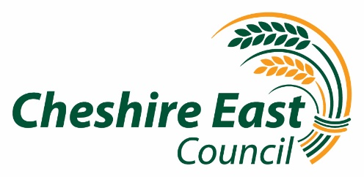
8 June 2020
Dear Headteacher/Parent

Important Update: Phased wider opening of Cheshire East schools

Following our letter to you on 20 May 2020, as promised we have continued to monitor the situation and we are currently reviewing our approach to the wider opening of Cheshire East schools based on the information released on Friday 5 June 2020 which indicates the r rate in the NW is above 1. We appreciate this is an anxious time for families and schools across the borough and aim to provide an update by Wednesday. This will enable us to review the latest evidence and have discussions with the DfE and other NW local authorities.
We are very aware of the anxiety of parents, children and young people and school staff caused by the current restrictions but we need to make sure any return to school is safe. We also understand the impact on children’s physical and emotional well-being and will continue to work with our schools and partners to look at the support that can be offered for those children and young people for whom it is not safe to return to school.
We aim to be able to write to schools and parents on Wednesday and will publish these letters on our website.
In the meantime, please stay safe.
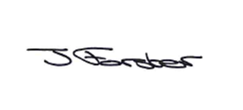 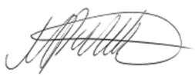 . 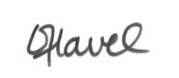
Jacky Forster  Director of Education and Skills | Mark Palethorpe  Executive Director of People | Cllr Kathryn Flavell  Portfolio Holder for Children and Families

