Bollington St. John’s Church of England
Primary School
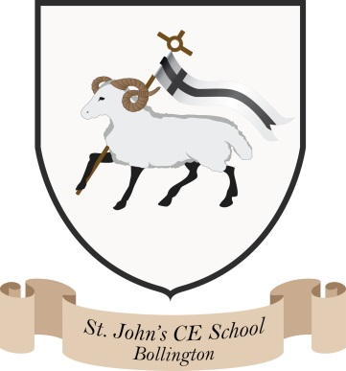
Where talent grows
Head Teacher: Mrs M. Walker
Head of Teaching, Learning and Assessment: Mrs E. Watson
“Whatever you do, work at it with all your heart, as working for the Lord”
Colossians 3:23

SEVERE WEATHER POLICY

School staff make every effort to reach the school when the weather is bad, but there are occasions when, by virtue of the position of the village or issues with Grimshaw Lane, the school is unable to open. Thus, in the event of inclement weather at the beginning of the day, parents should remain with their children until a member of the teaching staff arrives, as a decision to shut the school may not be made until the start of morning register.

Parents are asked to check the school website www.bollingtonstjohns.co.uk if in any doubt, or phone the school. Silk FM Radio 106.9 will also announce any school closures.

Parents should also note that they may have to make special arrangements to collect their children during the periods of bad weather. They should ensure that a member of staff is advised if they take their children home early.

Date: November 2023

