Bollington St. John’s Church of England
Primary School
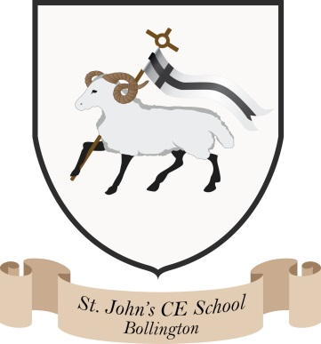
Where talent grows
Head Teacher: Mrs M. Walker
Head of Teaching, Learning and Assessment: Mrs E. Watson
“Whatever you do, work at it with all your heart, as working for the Lord”
Colossians 3:23
Marking Policy

Pupils are entitled to:
Regular marking that acknowledges their efforts and clearly shows them how they can make progress.

Staff are entitled to:
Have a reasonable workload that makes marking loads manageable yet facilitates effective assessment.

In responding to pupils’ work, all marking must:
- acknowledge the positive aspects of the work and reinforce success
- identify errors and provide constructive advice for improvement
- show sensitivity to the needs and abilities of individual pupils
- provide advice in language which can be understood by pupils
- give feedback to pupils frequently and promptly
- encourage dialogue between pupil and teacher

Why mark?
- To assess children’s progress
- To provide children with the help they need to progress
- To consolidate and reinforce what is good about a child’s work
- To encourage children to reflect on their work and to develop self-evaluation
- To ensure that children are producing their best effort and meeting agreed standards of handwriting and presentation
- To recognise and acknowledge success

When do we mark?
- As soon as possible after completion and before the book is returned for the next relevant lesson
- During the lesson with a child if appropriate
- Homework must be marked and feedback provided before the next homework activity is set
- It might be appropriate for some children to assess their own/peer work during a lesson

How do we mark?
- In green and pink pen to highlight strengths and indicate targets (tickled pink, green for growth)
- In a legible handwriting style
- Relating written comments to relevant learning objectives
- Providing encouraging remarks, praising success
- Giving practical advice that children can act upon
- Avoiding negative, demoralising or humiliating comments

Marking Conventions:
- ‘Verbal feedback’ can be used to indicate that verbal feedback has been given
- Key words spelt incorrectly will be identified using a line underneath
- In KS1 the teacher should identify selected misspelt words to address with the class
- Teachers will identify a limited number of relevant corrections for spelling, including focus and high frequency words. The children should try to learn and memorise the words. In KS2 these will be written in English/homework books
- Missing or incorrect punctuation will be selectively identified i.e. a circle will be used to identify missing or incorrectly used capital letters
- Mistakes should be crossed out by the child with a neat line
- A word, sentence or phrase highlighted in green indicates that the child needs to improve it (green for growth)
- In maths, teachers will use Draw it! Make it! Explain it! Teach it! Model it! prompts in order to support pupils and deepen their understanding
- Use of an effective word, phrase, sentence or paragraph should be highlighted in pink (tickled pink) – there may also be an indication of why the teacher regards this as effective
- When appropriate children will assess their learning , for example children will put a red, green or amber dot next to their learning objective to indicate how well they feel they have understood it
- Marking codes are shared with the children along with their targets

Date: November 2023

