Bollington St. John’s Church of England
Primary School
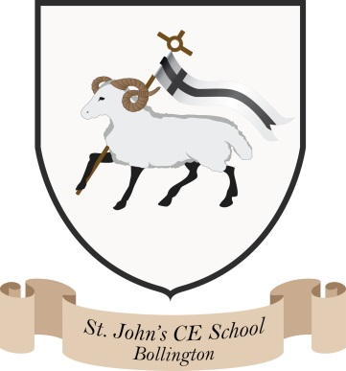
Where talent grows
Head Teacher: Mrs M. Walker
Head of Teaching, Learning and Assessment: Mrs E. Watson
“Whatever you do, work at it with all your heart, as working for the Lord”
Colossians 3:23
What is Phonics?

Phonics is an essential strategy that children are taught as part of the process of learning to read.

Children are taught to:
- Say the sounds that individual letters make
- Say the sounds that different combinations of letters make e.g. ‘sh’ and ‘th’ (digraph), ‘igh’ and ‘air’ (trigraph)
- Blend these sounds together, from left to right, to read a word

Children can then use this knowledge to ‘de-code’ unfamiliar words as they read.
What happens in Phonics lessons?
From Reception to Year 2, children receive daily phonics lessons in line with the ‘Letters and Sounds’ guidance from the Department for Education.
We follow the comprehensive planning from Monster Phonics to support the children's daily learning. Monster Phonics is designed as a whole-class scheme for children in Reception and Key Stage 1 and as an intervention in Key Stages 1 and 2, with all resources mapped against the Letters and Sounds phases 1 to 6 and the KS1 Spelling Curriculum. The colour-coded grapheme system is unique to Monster Phonics; each coloured grapheme is paired with a monster character that makes the same sound to give audio- visual prompts that help children ‘see’ each sound within a word and pronounce it correctly. Stories, songs and activities are carefully woven into these lessons which are highly engaging. Colour-coded flash cards, word charts and PowerPoints make the teaching of the Common Exception and High-Frequency words far easier.

Phonics Overview

Phase One
Supports the importance of speaking and listening and develops children’s discrimination of sounds, including letter sounds.
PhaseTwo
The children learn to pronounce the sounds themselves in response to letters, before blending them. This leads to them being able to read simple words and captions.
Letters: s, a, t, p, i, n, m, d, g, o, c, k, ck, e, u, r, h, b, f, ff, l, ll, ss
Tricky Words: the, to, I, no, go

Phase Three
Completes the teaching of the alphabet and moves on to sounds represented by more than one letter. The children will learn letter names and how to read and spell some tricky words.
Letters: j, v, w, x, y, z, zz, qu, ch, sh, th, ng, ai, ee, igh, oa, oo, ar, or, ur, ow, oi, ear, air, ure, er
Tricky Words: he, she, we, me, be, was, my, you, they, her, all, are

Phase Four
The children learn to read and spell words containing adjacent consonants.
Tricky Words: said, so, have, like, some, come, were, there, little, one, do, when, out, what

Phase Five
The children broaden their knowledge of sounds for use in reading and spelling. They will begin to build word-specific knowledge of the spellings of words.
Sounds: ay, ou, ie, ea, oy, ir, ue, aw, wh, ph, ew, oe, au, ey, a_e, i_e, u_e, o_e
Tricky Words: oh, their, people, Mr, Mrs, looked, called, asked

Phase Six
This focuses more sharply on word-specific spellings. It encourages children to become fluent readers and increasingly accurate spellers.

What can I do at home to support my child?

- It is really important for your child to learn the correct pronunciation of each sound. We will teach this on a daily basis but reinforcing this at home is great too! Follow the link below to hear the correct pronunciation of all the phase 2 and 3 sounds.
- When reading with your child at home, try to break up (segment) unfamiliar words into a series of sounds e.g. b-r-u-sh, sh-a-m-p-oo. Combine (blend) the sounds together to try to read the word.
- Play games like ‘I spy’ that encourage your child to look for objects that begin with a certain sound e.g. I spy with my little eye, something beginning with the sound ‘ch’.
- Learn some ‘tricky’ words with your child (words that cannot be decoded phonetically). Lists of these are handed out at the Phonics Workshop and are relevant to the phase your child is working on. If you do not have a copy please ask your child’s class teacher.
- There are a wealth of interactive games and activities available online.

We have found the following sites particularly useful:
https://www.phonicsplay.co.uk/InteractiveResources.htm
https://www.bbc.co.uk/bitesize/articles/zt27y4j
https://www.ictgames.com/mobilePage/literacy.html

